**Project**

Name of project: CASSANDRA - An IoT system for long-term monitoring and alerting vital heart problems

Competition Track: Planet NI

**Contact Information**

Name:  Phạm Khôi Nguyên

School:  International University – Vietnam National University (VNU)

Department:  Biomedical Engineering   Year:  2013 - 2017

Email: phamkhoinguyen1995@gmail.com       Mobile Phone: + (84) 914 118 896

Mailing Address:  Room 34, Binh Phu Apartment, Ward 10, District 6, Ho Chi Minh City

**Project Adviser**

Name:  Dr. Lê Quốc Trung

Title:  Lecturer of University                    Organization: International University – VNU

Email: lequoctrung@gmail.com             Mobile phone: + (84) 915 538 938

**Team Members**

1. Name:  Cù Gia Huy

Email:  [huycu17@gmail.com](mailto:huycu17@gmail.com)

Mobile phone:  + (84) 969 074 690

1. Name:  Nguyễn Thanh Trúc

Email:  [ngthanhtruc.iuetv@gmail.com](mailto:ngthanhtruc.iuetv@gmail.com)

Mobile phone:  + (84) 166 262 7929

**Project Paper**

1. **Abstract**

Cassandra is an Internet of Things system dedicated to provide cardiac surveillance for remote healthcare, sport and clinic. The system consists of a chest - worn device that measures ECG signal, an intermediate device to stream data, an algorithm to detect heart problems and a management software. The team hopes to bring forward the era of homecare where patients at risk of CAD can have access to cardiac healthcare while staying at home.

1. **Project Introduction**

**Problem**

For many decades, Cardiovascular Disease (CAD) is the leading cause of death during patients’ hospitalization across the globe. As reported by the World Health Organization (WHO), there was about 17.3 million people around the world died from CAD in 2008, representing 30% of all total cases of death globally.

**Innovations**

ECG has long been considered as a gold standard for diagnosis of CAD because it is fast, cheap and reliable. Moreover, ECG device can technically be built into very small, compact wearable that is suitable for remote healthcare. In other to further improve its effectiveness, the device must have the ability to connect directly with the hospitals and integrated with a compatible software that helps doctors make faster and better diagnosis.

**How we use our NI packages**

Signal simulation and product prototyping is accomplished using National Instrument (NI) LabVIEW. Then NI myRIO is developed into an intermediate device that receives ECG data and performs peak detection. Simultaneously, the algorithm is developed and its accuracy is validated using Matlab.

**3. Design Methodology**

|  |
| --- |
| Project Schedule |
| **5 November**  **1 December**  **1 January**  **27 Jan**  **Analysis, Plan** 5 – 23 Nov  **Build Hardware** 17 Nov – 5 Jan  **Server and algorithm** 10 Dec – 20 Jan  **Testing** 15 Dec – 5 Jan  **Implement on NI MyRIO** 6 – 23 Jan  **Report** 6 – 26 Jan  **Today** |

Product development timeline

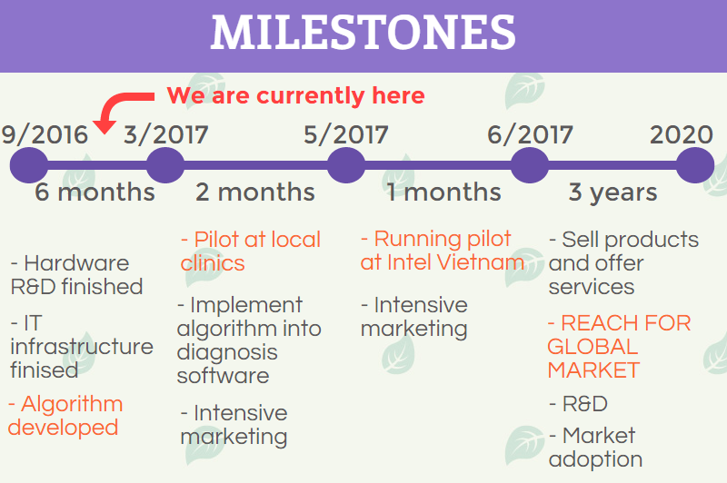

Commercialization timeline

**4. Design Architecture**

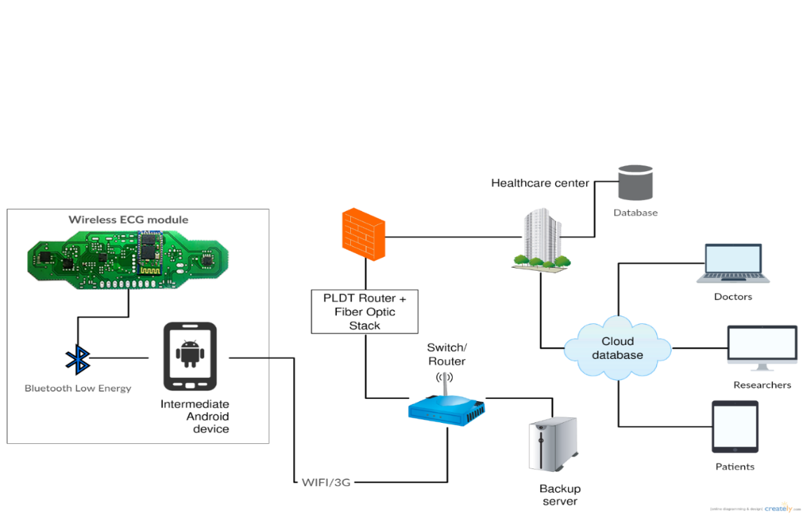

**Figure 5.** Schematic of our complete ecosystem

**Component description:**

1. Wireless ECG module: a compact wearable that acquires ECG signal on 4 crucial leads, including 3 limb leads (I, II, III) and 1 chest leads (V1) and transmit data via Bluetooth LE 4.0.

2. Intermediate devices: android, iOS smartphones or stationary hub developed with NI myRIO for receiving and streaming data to the cloud

3. Dedicated server: receive data package and perform disease detection.

4. Database: storing diagnosis result and data records

5. Management platform: website for doctors, patients and researchers to access data records

**5. Functional description**

1. *Wireless ECG module*

*A. PROTOTYPING*

The test module consists of three components: AD8232 Single Lead Heart Rate Monitor, Arduino Nano and HC-05 Bluetooth module. There is a LED indicator that blinks to the rhythm of heartbeat [4].

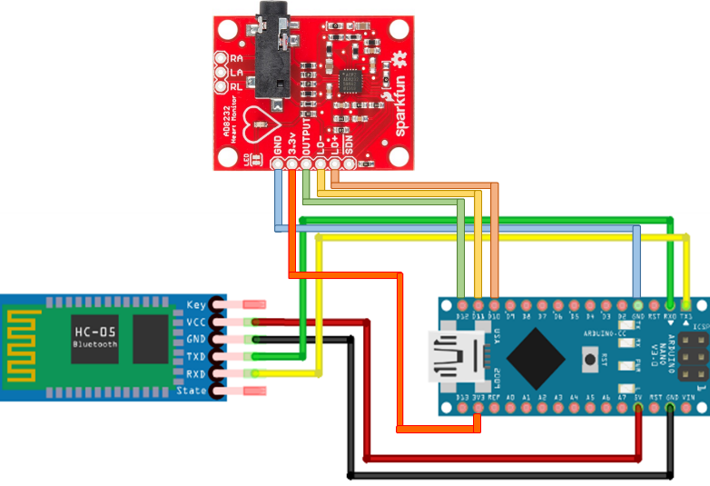

**Figure 7. Wiring network of wECG prototype. See appendix for more information**

Connection table

|  |  |  |
| --- | --- | --- |
| Board Label | Pin Function | Arduino Connection |
| GND | Ground | GND |
| 3.3v | 3.3v Power Supply | 3.3v |
| OUTPUT | Output Signal | A0 |
| LO- | Leads-off Detect - | 11 |
| LO+ | Leads-off Detect + | 10 |
| SDN | Shutdown | Not used |

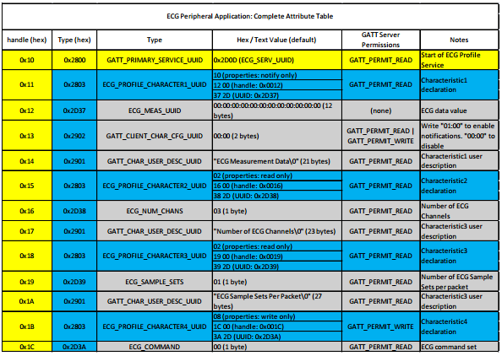

The complete data package of HC-05

*B. FINALIZED PRODUCT*

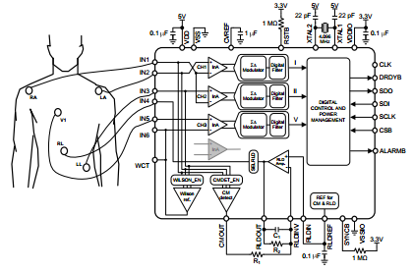

*Principle design*

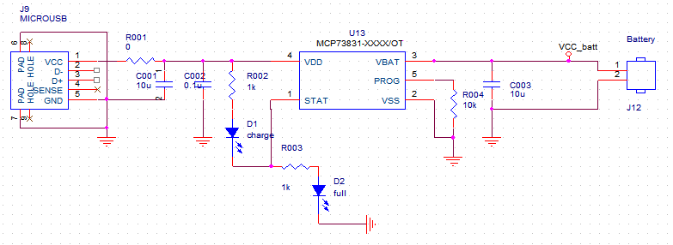

*Battery charger circuit*

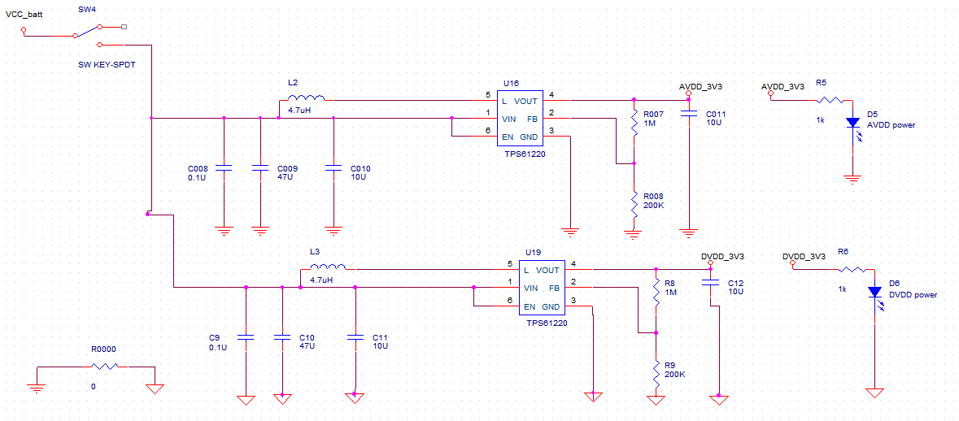

*Voltage regulator circuit*

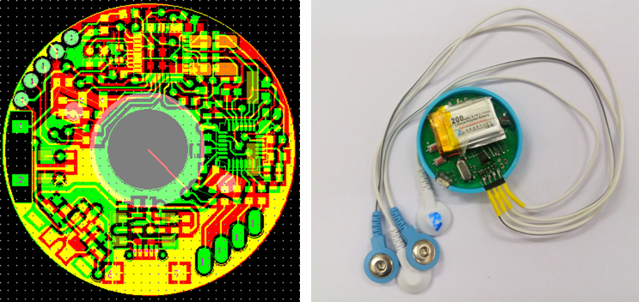

*Components assembly and product finalization*

1. *Intermediate devices*
2. *MOBILE APPLICATION*

|  |  |
| --- | --- |
| Platform | Utilization |
| Ionic framework | Create cross platform application |
| ngCordova | JavaScript library for controlling geo-location sensor and Bluetooth |
| Chartist.js | Create graphical result |

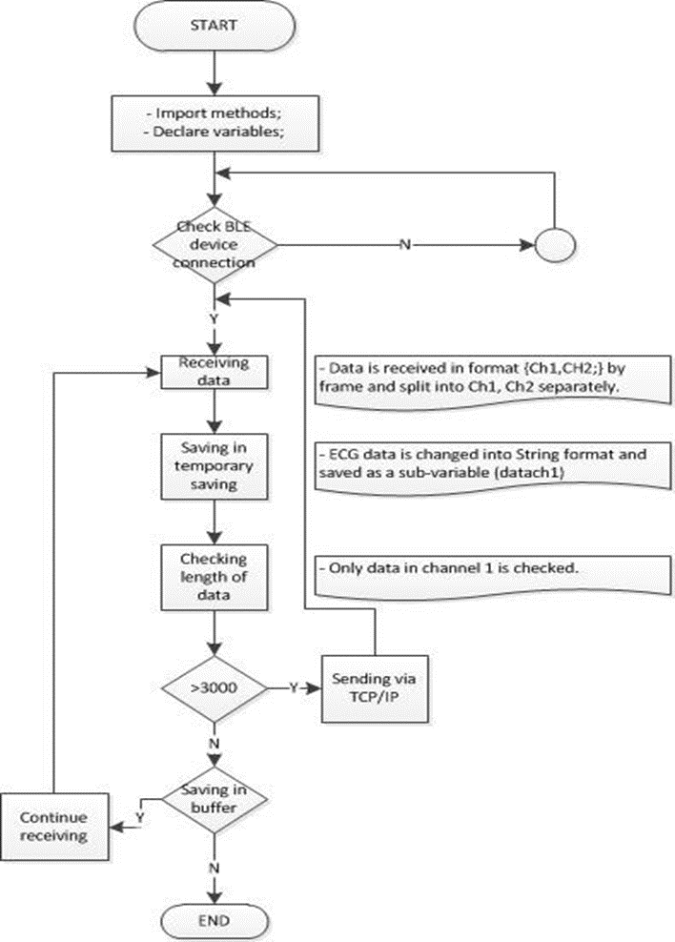

*Flowchart of ECG Bluetooth program*

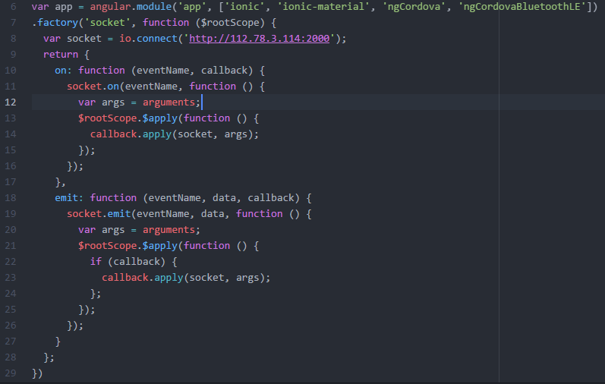

App initialization and connection establishment using socket.io

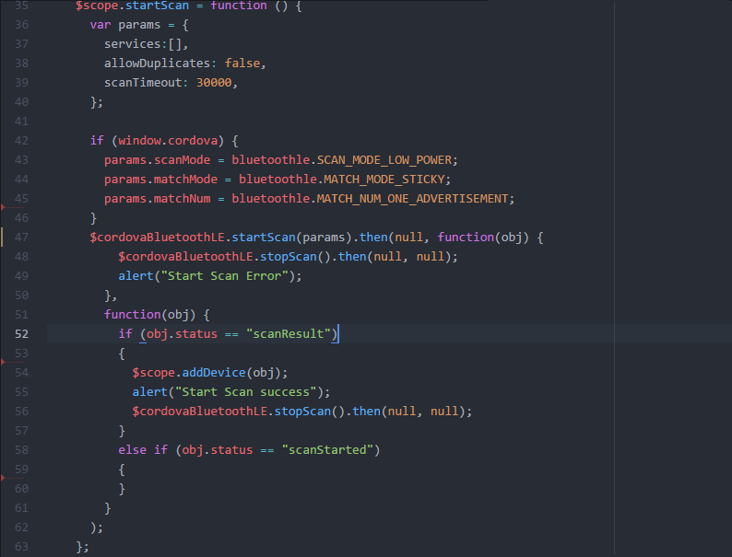

Bluetooth scanning

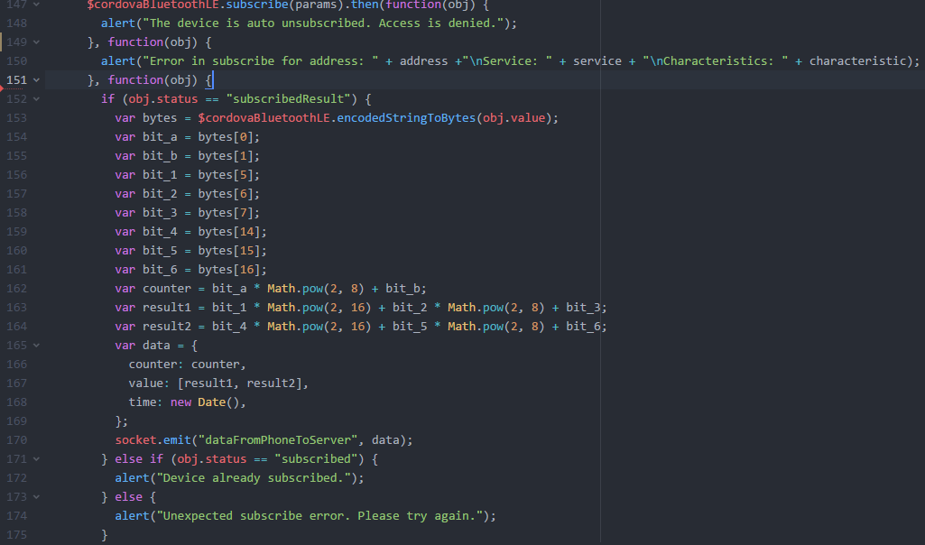

Subscribe to a service, receive and process data package (see table below), then stream data to server

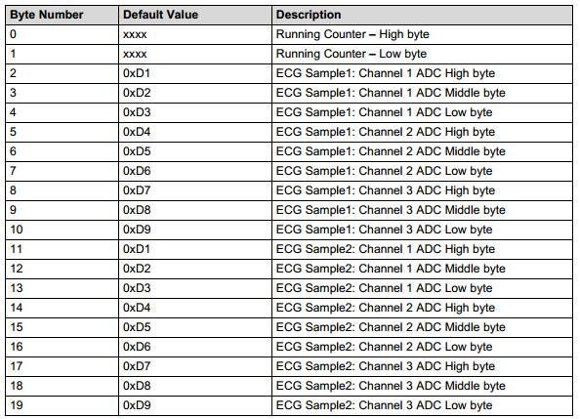

**Figure 12***: Signal package format*

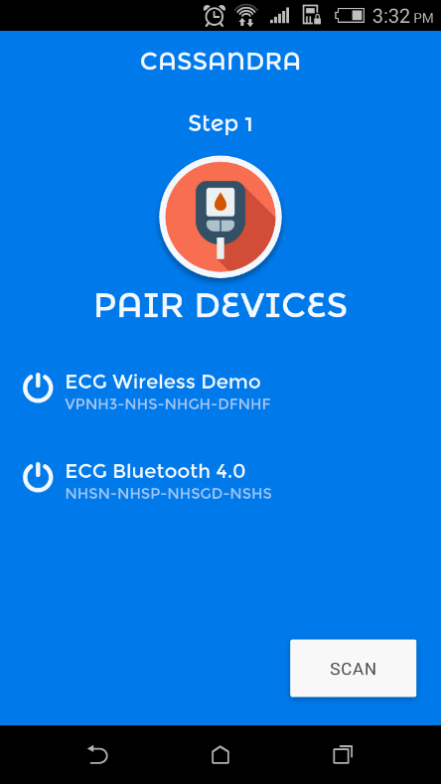 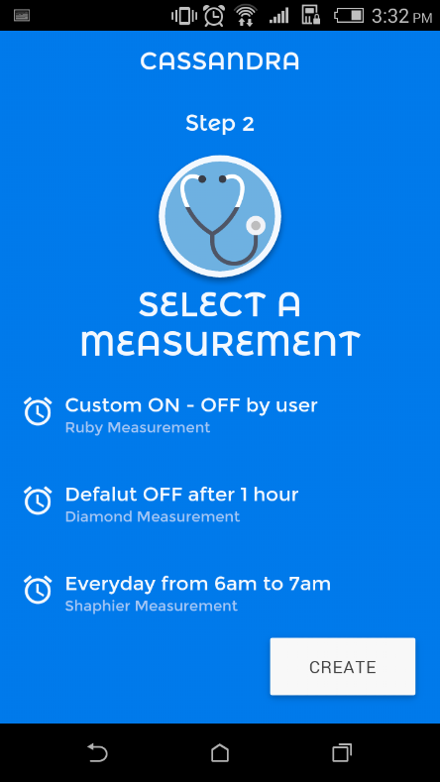 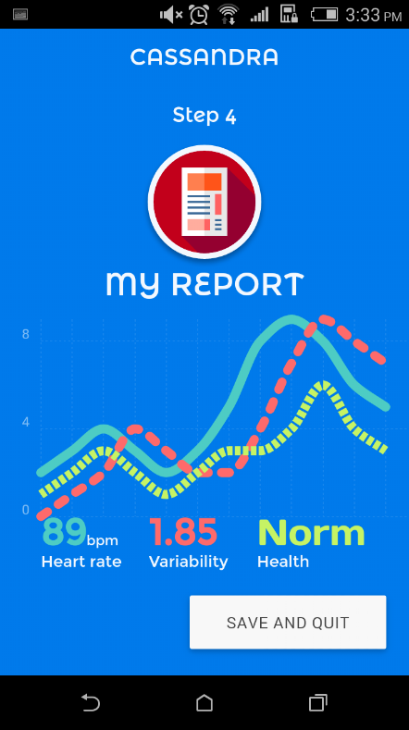

**Figure 4**. Application finalized as guiding steps

1. *STATIONARY HUB*

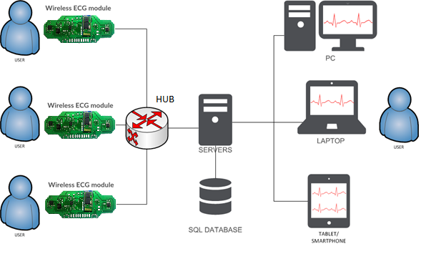

Figure 5: The hub is designed to replace mobile app for smart home or hospital integration.

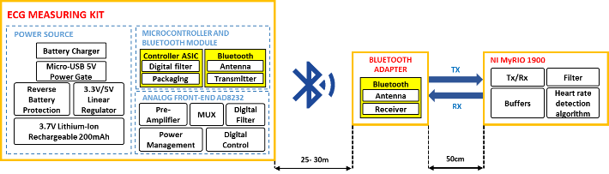

**Figure 6. Block diagram of the stationary hub and its interaction with the ECG module**

|  |  |
| --- | --- |
| **Component** | **Utilization** |
| Bluetooth adapter | * Includes 2 Bluetooth HC-05 modules * Works as wireless terminal receiver and transmitter to myRIO kit. * Transmission is 20 meters, which covers about 200 m2 area |
| NI myRIO kit | * Communicates with wireless healthcare device via Bluetooth connection and acquire the vital signals * The built-in FPGA Zynq 7010 analyzes wireless signal in real-time and process complex algorithms * 16 wECG devices can connect to the Hub at the same time |

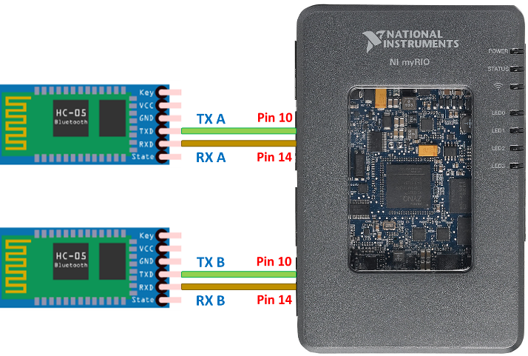

**Figure 8. Wiring network of the Data Hub**

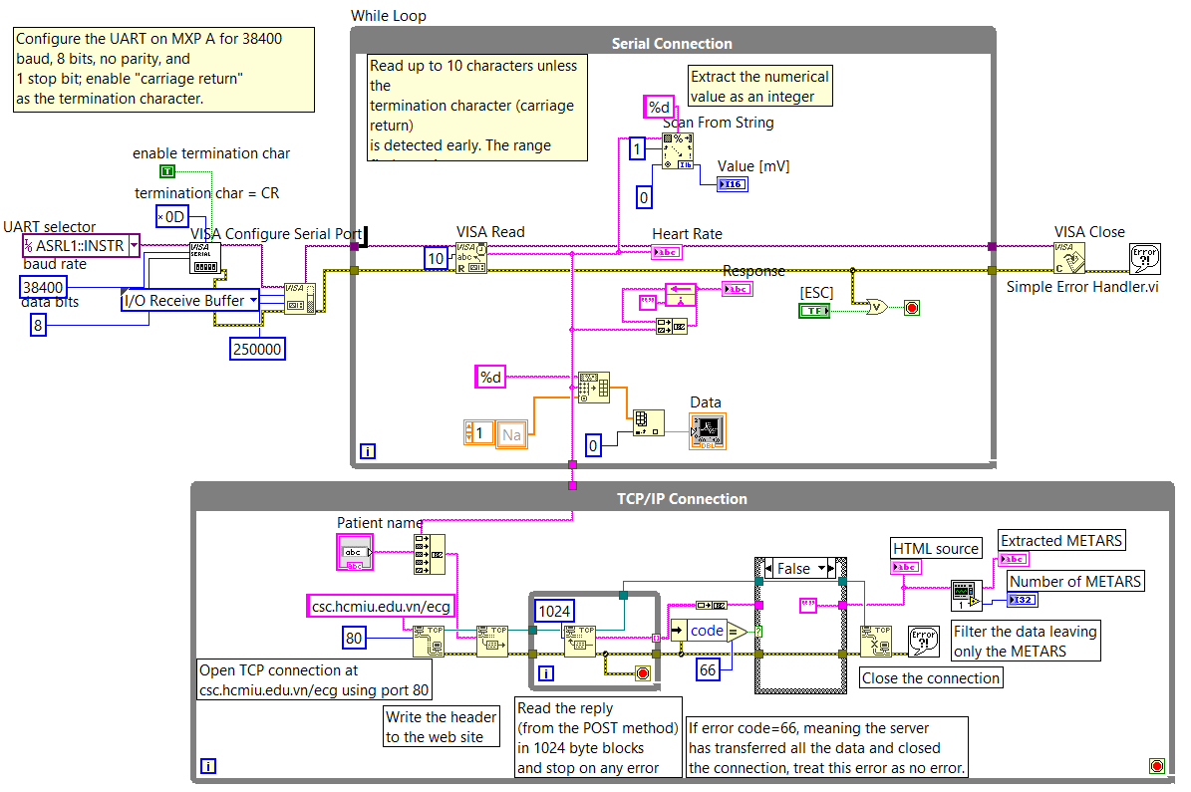

**Figure 9. Block diagram of NI Labview graphical user interface for NI myRIO programming**

1. *Dedicated server*
2. *IT INFRASTRUCTURE*

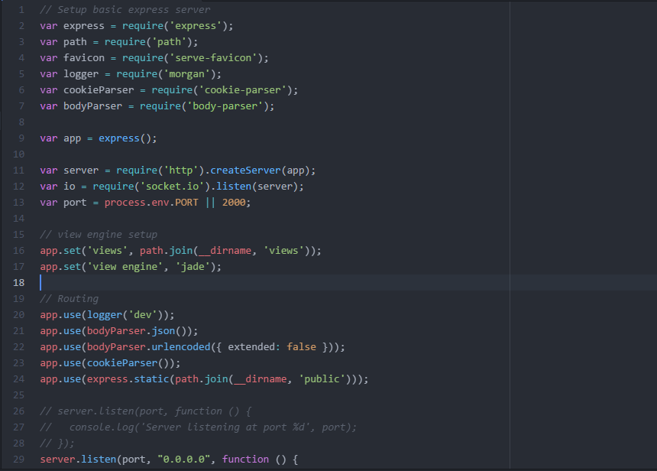

**Server initialization**

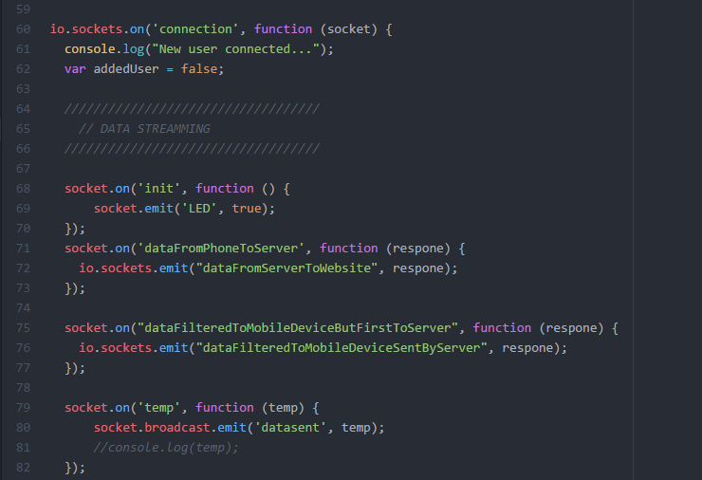

**Handle the data exchange with Hub and devices**

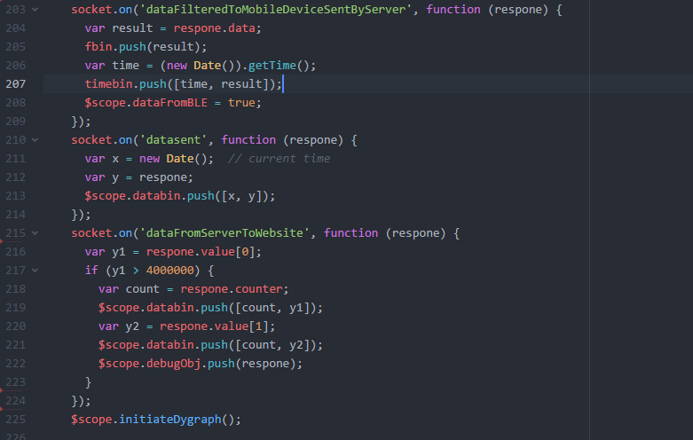

**Server send data to website and initialize plotting function**

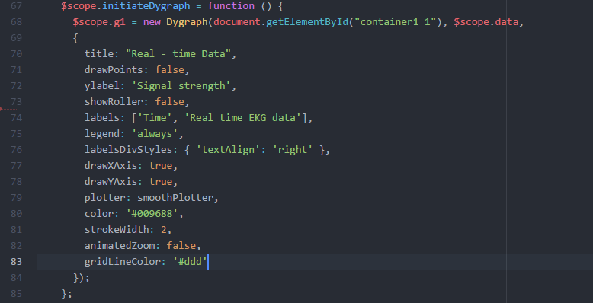

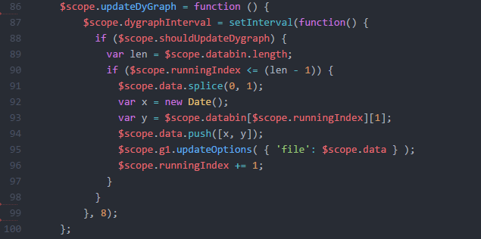

**Plotting functions**

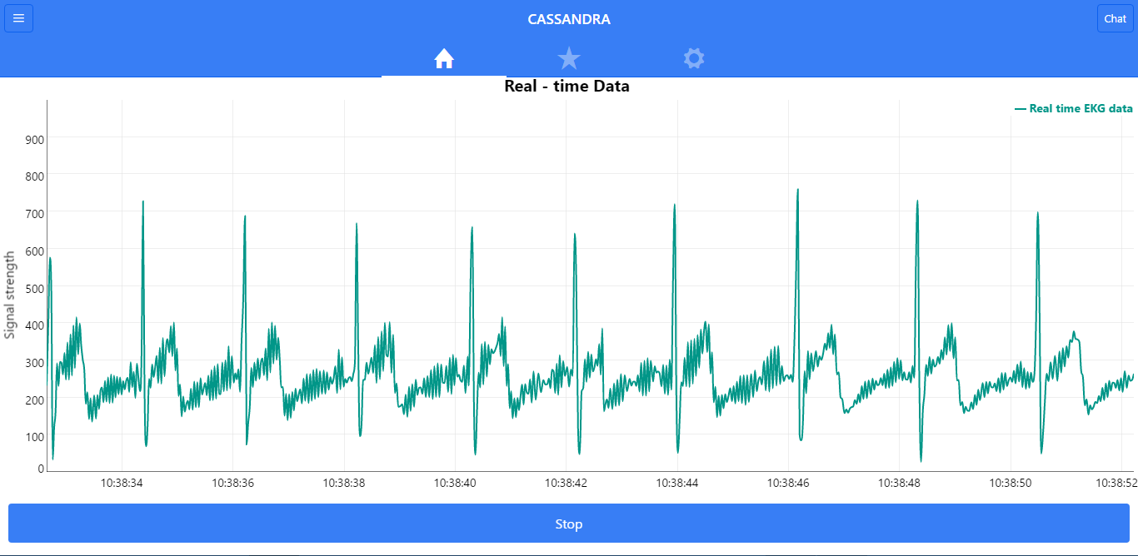

**Data streaming result**

1. **DISEASE DETECTION ALGORITHM**

The server also stores multiple Matlab file to handle the data package sent from the device or Hub. Analysis result is transferred back after calibration.

Wavelet Filtering

Baseline wander removal

Normalization

Input EKG signal

P wave absence?

Yes

Atrium damage

Delineation

**Figure 15**: Algorithm development (blue: finished, red: under development)

No

Q wave presence?

Yes

Irreversible myocardial infarct

No

Fast?

Yes

Myocardial ischemia

Tachycardia

Heart rate

No

No

STD in mirror leads?

Slow?

Yes

Yes

Myocardial infarction

Bradycardia

Chaotic?

No

No

Down

STD direction?

Yes

ST Deviation calculation

Arrhythmias

Up

Ischemia or posture changes

Peaked or inverted?

Yes

Myocardial infarction

T wave height calculation

No symptoms

No

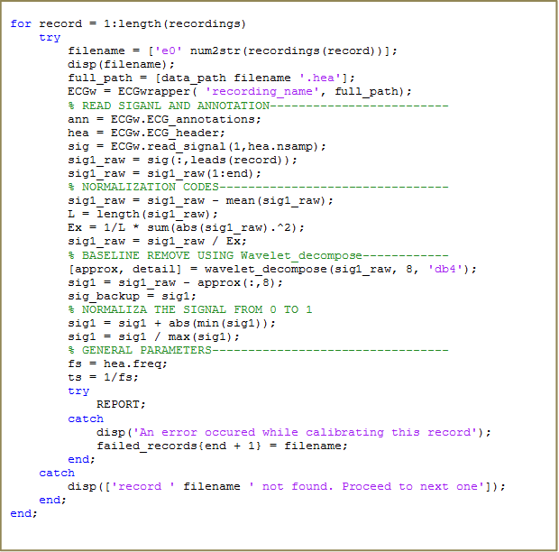

TASKS_HANDLE.m

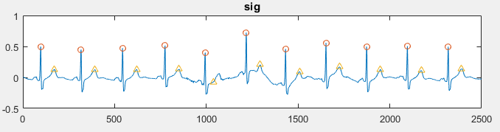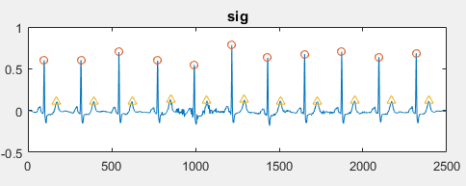

***Figure 18****: Baseline wander removal results*

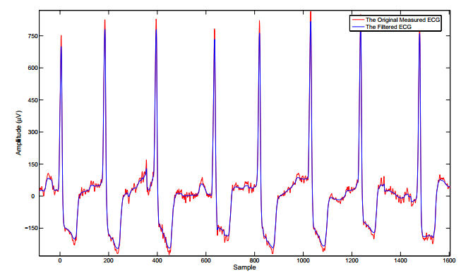

***Figure 19:*** *Noise removal result*

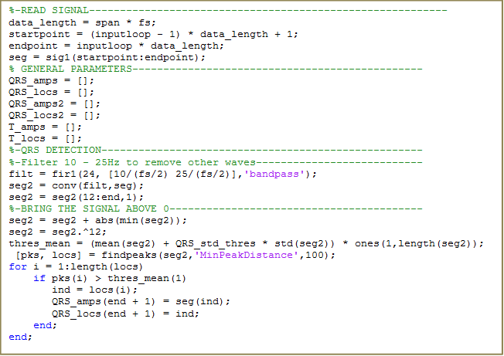

*R – peak detection*

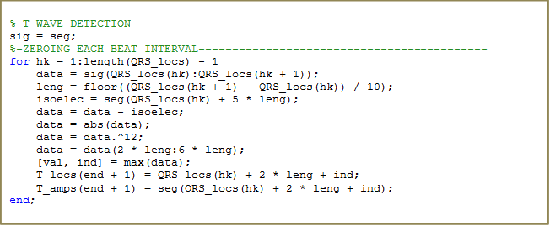

*T – peak detection*

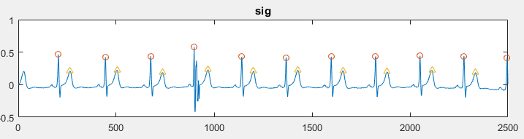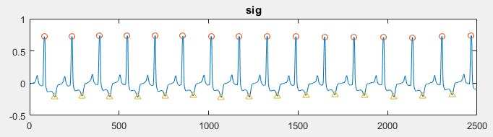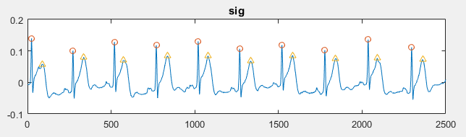

***Figure 20:*** *Peaks detection result*

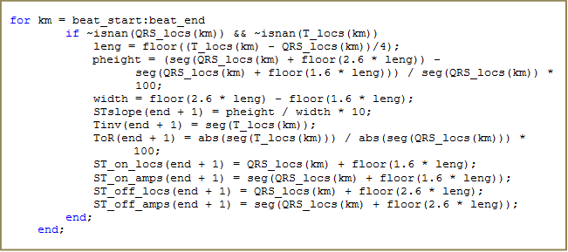

*ST segment detection*

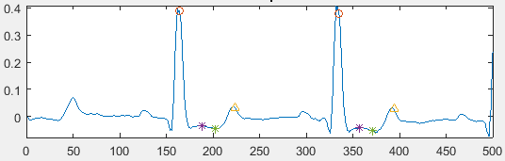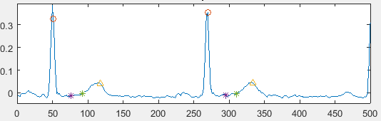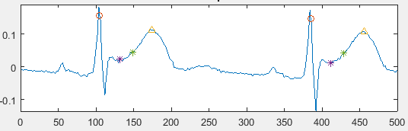

***Figure 21:*** *ST segment detection result*

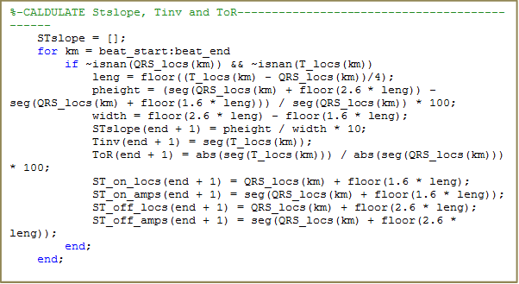

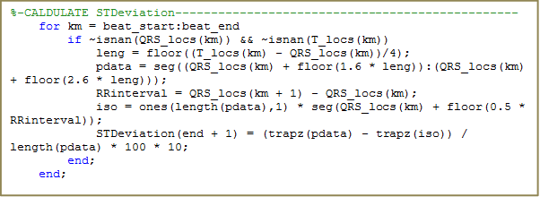

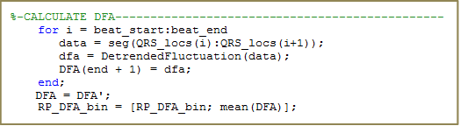

Functions to detect abnormal morphologies

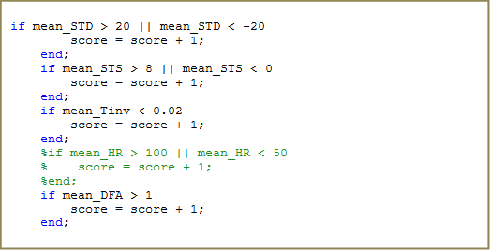

**Risk score system**

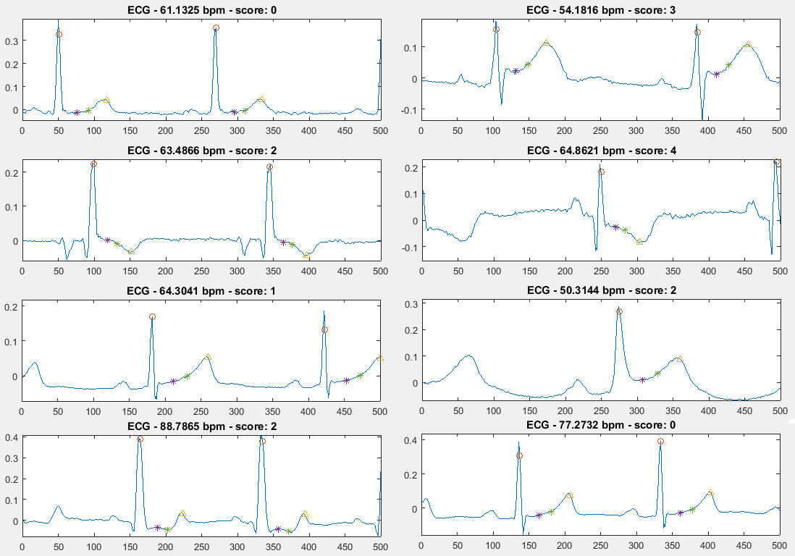

***Figure 23****: Scoring system creates the risk score for each of the data segment*

|  |  |  |  |  |
| --- | --- | --- | --- | --- |
|  | | Score | Description | Disease types |
| Valid | Normal | 0 | Normal EKG | Healthy |
| Caution | 1 | Small ST deviation or T inversion | Postures changes or anxiety |
| Risk | 2 | Transient ST deviation with DFA confirmation or with T inversion | Suspected of myocardial injury or ischemia |
| Danger 1 | 3 | Transient ST deviation, ST slope with DFA comfirmation | Diagnosis with ST elevation myocardial infarction |
| Danger 2 | 4 | Transient ST deviation, ST slope with DFA confirmation and T wave inversion | Diagnosis with ST depression myocardial infarction |

***Figure 27****: Table summary of disease classification with different risk scores*

**6. Results and Discussion**

**Challenges and solutions**

|  |  |
| --- | --- |
| **Challenges** | **Solutions** |
| Smartphone is required to run continuously with 3G connection. This significantly reduces our product’s reliability. | The hub developed with NI myRIO proves to be a powerful and reliable alternative to the mobile application. |
| The lack of Bluetooth protocol on NI myRIO is a critical problem. | We design a Bluetooth adapter that is compatible with NI MyRIO. |
| Data streaming using 3G network can suffer from latency. | Develop a remote desktop software using NI Labview to push data from NI myRIO directly to the computer via Uart port. |

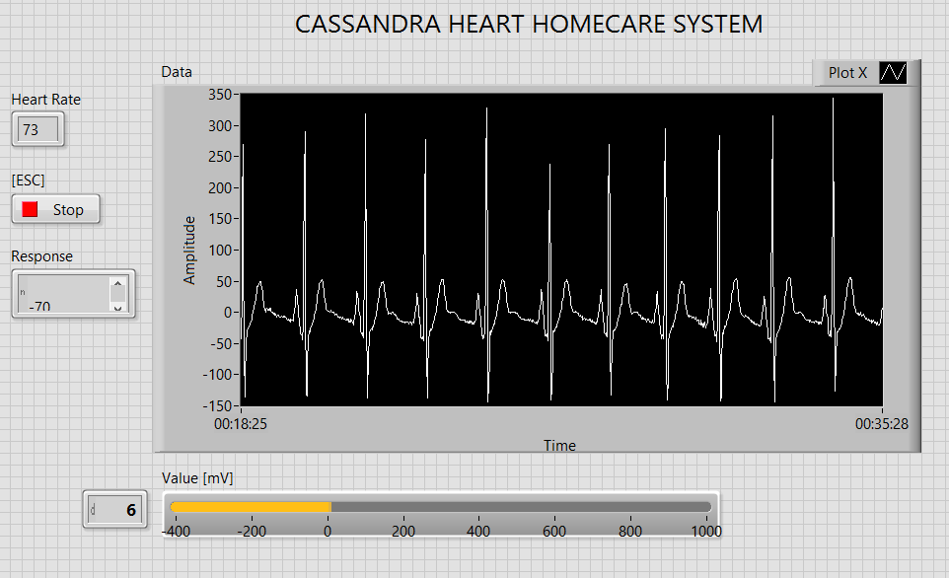

**Figure 12. LabVIEW graphical user interface on desktop**

**Benefits of using LabVIEW and NI tools**

NI MyRIO kit is chose to build the data hub because of two reasons. First, the kit is powerful enough to receive and process signal in real-time, which is really important to this project. Second, the NI LabVIEW is a user-friendly design software with Graphical designing method, which allows us to design and implement within 3 months.

**Commercialize plan**

The images below are taken from our pitching slides. The link is: https://magic.piktochart.com/output/18303396-cassandra-pitch-deck

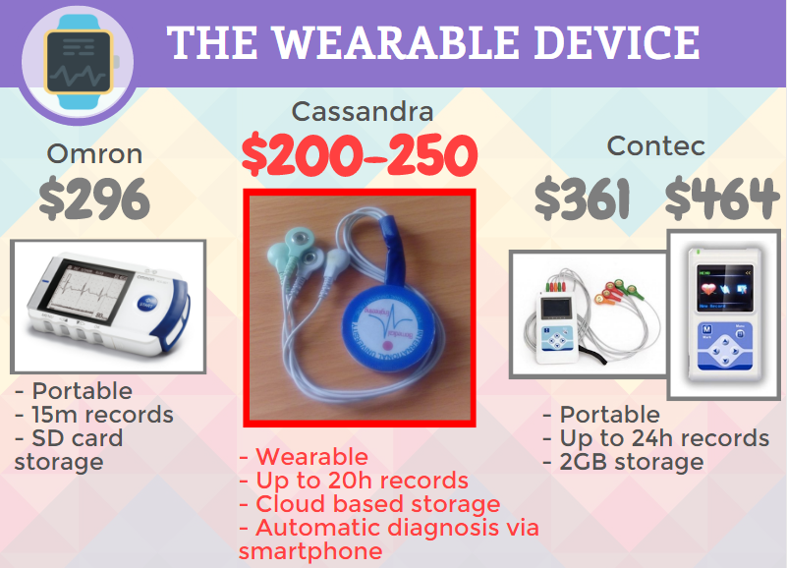

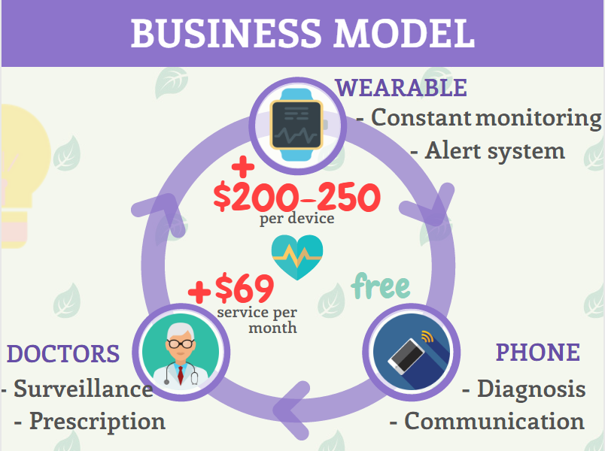

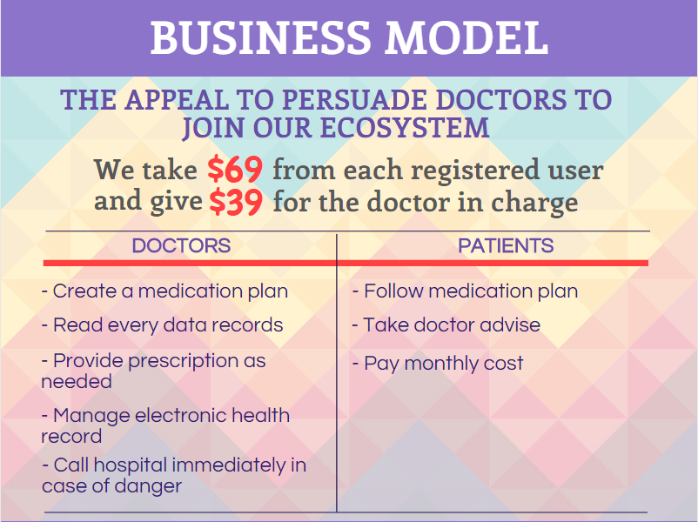

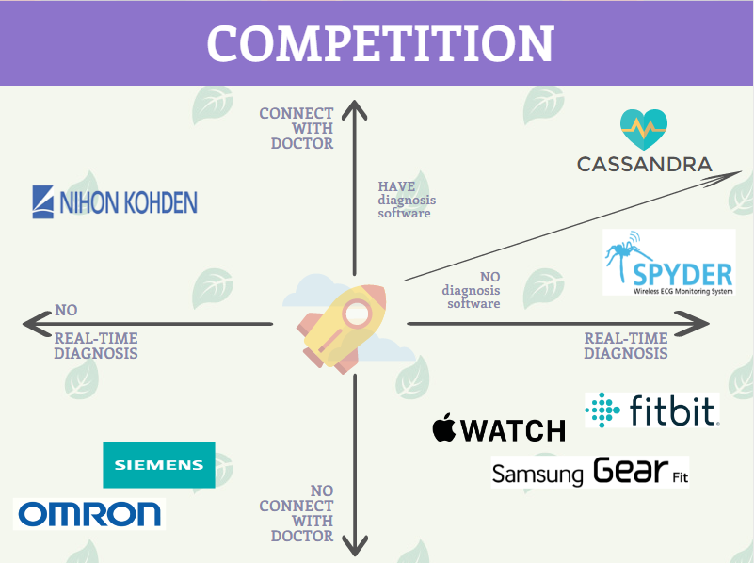

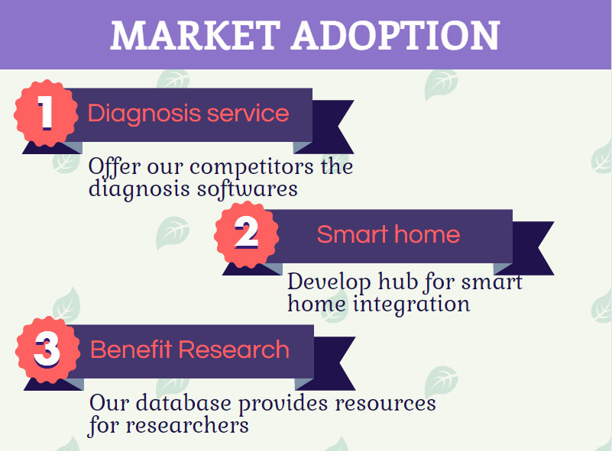 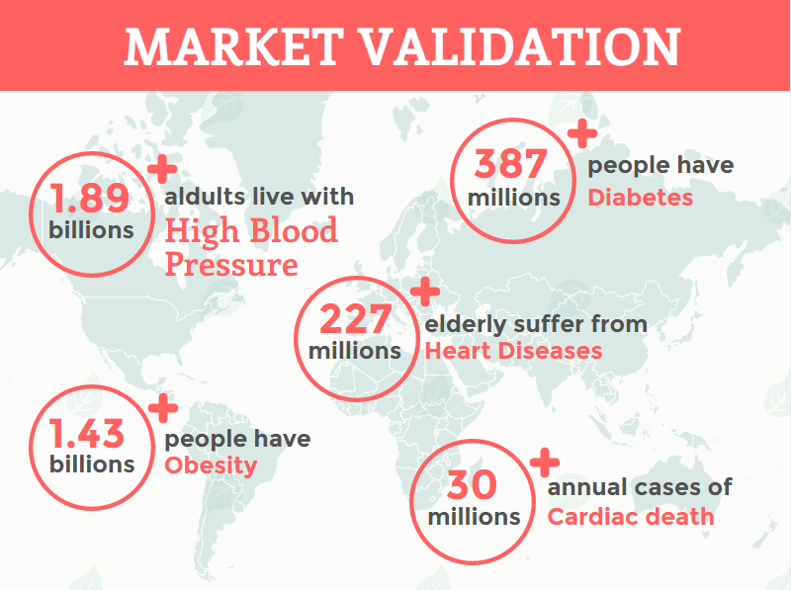 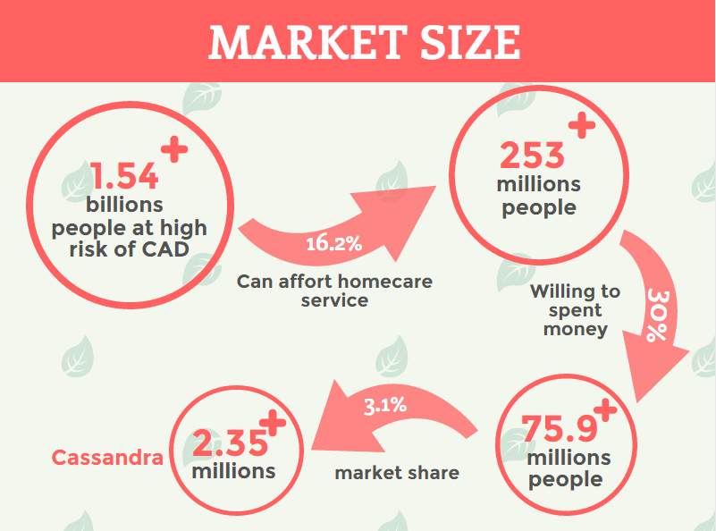 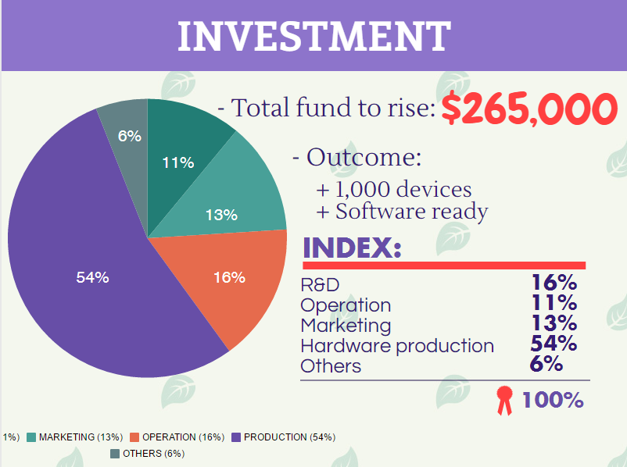

**7. Conclusion**

The result shows that the proposed Cassandra system can be used as that multi-signal monitoring for continuous ECG monitoring during daily activities. The wireless transceiver via BLE proved to be a potential choice due to its real-time transmission and low-power consumption. NI MyRIO shows its efficiency in signal processing. Furthermore, NI LabVIEW is an appropriate choice for product prototyping and development. For future applications, Cassandra with a wireless system is a potential solution for telemedicine, especially cardiac homecare.